**A**

**Project Report**

**on**

**“Home Automation using IoT”**

**Prepared by**

Kushang Darbar(18EC017)

**Under the guidance of**

Prof. Rajat Pandey & Dhara Patel

**Submitted to**

Charotar University of Science & Technology for Partial

Fulfillment of the Requirements for the Degree of

Bachelor of Technology

in Electronics & Communication

EC 249 – Mini Project-II

of 4 th Semester of B.Tech

**Submitted at**



**DEPARTMENT OF ELECTRONICS & COMMUNICATION**

**Faculty of Technology & Engineering, CHARUSAT**

**Chandubhai S. Patel Institute of Technology**

**At: Changa, Dist: Anand – 388421**

**April 2020**

**CERTIFICATE**

This is to certify that the report entitled “Home Automation using IoT” is a bonafide work carried out by Kushang Darbar under the guidance and supervision of Prof. Rajat Pandey & Dhara Patel for the subject Mini Project-II (EC249) of 4th Semester of Bachelor of Technology in Electronics & Communication at Faculty of Technology & Engineering (C.S.P.I.T.) – CHARUSAT, Gujarat.

To the best of my knowledge and belief, this work embodies the work of candidate himself, has duly been completed, and fulfills the requirement of the ordinance relating to the Subject specified for 4th semester of the University and is up to the standard in respect of content, presentation and language for being referred to the examiner.

Under the supervision of,

Prof. Rajat Pandey Dhara Patel

Assistant Professor Assistant Professor

Department of Electronics & Department of Electronics &

Communication, Communication,

C.S.P.I.T., CHARUSAT-Changa. C.S.P.I.T., CHARUSAT-Changa.

Dr. Trushit K. Upadhyaya

Head of Department,

Department of Electronics & Communication

C.S.P.I.T., CHARUSAT- Changa, Gujarat.

Chandubhai S Patel Institute of Technology (C.S.P.I.T.)

Faculty of Technology & Engineering, CHARUSAT

At: Changa, Ta. Petlad, Dist. Anand, Gujarat - 388421

**ABSTRACT**

The project made is “Home Automation using IoT” which describes how Internet of things made a drastic change in human lives. This project includes a small part of automation system like controlling a bulb switching using google assistant. For this controlling facilitation, IFTTT (If This Then That) protocol is being used in this projects which provides us the facility to create our own triggering or voice commands which when given, the operation is performed accordingly. At the backhand, this protocol is used to convert the commands into machine level language and in my project it is used for communication between smartphone and Node MCU (ESP8266). When we give a command to google assistant, the signal is passed on to Node MCU further provided to the relay module connected to it. Thus, the appliances which are connected to the relay module are operated through Wi-Fi (Wi-Fi module integrated in Node MCU).



**ACKNOWLEDGEMENT**

I take this opportunity to express my profound gratitude and deep regards to my guide Prof. Rajat Pandey & Dhara Patel and coordinator of E&C department of CSPIT, Prof. Trushit Upadhyaya, for their exemplary guidance, monitoring and constant encouragement throughout the course of this project. The blessing, help and guidance given by them time to time shall carry me a long way in the journey of life on which I am about to embark.

Kushang Darbar(18EC017)

CSPIT, CHARUSAT



**TABLE OF CONTENT**

Abstract…………………………………………………………………………………...i

Acknowledgement………………………………………………………………………...ii

List of Figures……………………………………………………………………………iv

Abbreviations……………………………………………………………………………..v

**Chapter 1: Introduction of project………………………………………………………..1**

1.1 Problem and Solutions……………………………………………………………1

1.2 Literature Survey………………………………………………………………….5

**Chapter 2: Project Description …………………………………………………………..6**

2.1 Block Diagram……………………………………….…………...………………6

2.2 Circuit Diagram…………………………………………………………………..7

**Chapter 3: Components and Its Details………………………………………………….8**

3.1 List of Components………………..…………………………………….……….8

3.2 Details of components……………… ………………………………….………..8

**Chapter 4: Implementation……………………...……………………………………….10**

4.1 Hardware Implementation…..……..…………………………………….……....10

C**hapter 5: Applications and Future scope.......…... .…………………………………..11**

5.1 Applications…………….…..……..…………………………………….……….11

5.2 Future Scope.……………. ……………… …………………………….……….11

**Conclusion……….………………………………………….……………………………12**

**Reference………………………..………………………………………………………...13**

**Datasheets of Components…….………….……………………………………………...14**

**LIST OF FIGURES**

Fig 1 - Block Diagram

Fig 2 - Interfacing Diagram

Fig 3 - Node MCU

Fig 4 - Relay

Fig 5 - Wires

Fig 6 - Hardware

**ABBREVIATIONS**

HAM Home Automation System

IoT Internet of Things

MCU Microcontroller Unit

IFTTT If This Then That**CH 1: INTRODUCTION**

**1.1:Problems and Solutions**

The world today is facing a lot of problems in their daily life due the manual operated systems which are very hectic and time consuming. Also in the industries, the systems are working by manual operations which leads to higher risk factors due to human errors and irregularity. Due to lack of Internet and automation systems, the people of ancient times faced a lot of problems as they had to perform the tedious tasks manually. Also the major problem faced is the lack of precision and accuracy. We all just dream of having the entire task done automatically for us. Home automation system is one of the systems that fits well in this scenario. Home automation or smart homes can be described as a technology which is used within the home environment to provide comfort, security, convenience, and energy efficiency to its user or occupants. Home Automation includes a concept which has a real time controlling and monitoring of multiple domestic appliances. This project is majorly built upon the concept of Internet of Things. This project has determined to implement seamless integration of all the appliances in the home via a central console. Our project drastically changes the way in which we communicate with our home appliances. It also reduces the need for any personal contact with any of them as it delivers a wholesome experience of wireless, voice controlled system. We plan to implement this project with the help of Arduino boards or Node MCU with the capability to perform IoT(Internet of Things) operations. Installing the boards in every home appliance will allow us to establish real-time communication with them help of Wi-Fi. Internet of Things(IoT) has the capability to connect with billions of intelligent objects which is used to sense & collect the data and also communicate with surrounding people using mobile, wireless and sensor technologies. Main objective of IoT is to manage and control physical objects around us in a more intelligent and meaningful manner and also improve quality of life by providing cost effective living including safety and security, also sometimes entertainment. Smart objects can be interfaced for useful contextual data autonomously and sent to remote application servers for offering context awareness or location based services. Here, "context" can refer to any location information, surrounding environment, people & objects that are nearby so that adaptive and personalized services can be provided to the user.

According to CISCO, it is estimated that 40 Billion devices would be connected to the Internet by 2020. Currently, the advancement in cloud computing and data analytics allows intelligent systems to process and analyze the data in a more efficiently. Though there are many IoT applications, authors propose a unique mobile based home automation solution that can facilitate people to control home appliances using their personal android smart phones anywhere and anytime. Among many IoT applications, smart homes play an important role in realizing smart cities. Smart homes can be useful for remote monitoring and controlling electrical appliances. Concept of Smart Home interfaced inside the homes using smart & intelligent physical infrastructure. The present Government of India(GoI) has proposed to develop 100 smart cities across the country which will create a huge demand for concept of home automation in near future. In "smart home" the word "smart" means context aware which can be realized using Information and Communication Technology (ICT) and IoT.

There is an increasing demand of automated systems so that human intervention is reduced. This documentation focuses on a system that provides features of Home Automation relying on Internet of Things to operate easily, further adding to that it can be flavoured with a camera module which provides home security. The android app basically converts Smartphone into a remote for all home appliances. Security is achieved if motion sensors are interfaced, thus movement is sensed at the entrance of the house and notification would be sent that contains a photo of house entrance in real time. The notification will be received by the owner of the house via internet such that app can trigger a notification. The owner can raise an alarm if there is any intrusion or he/she can toggle the appliances like opening the door if the person is a guest. The user can make use of this system to control switching on of lights, fan, AC, etc. automatically. We can also incorporated a smoke sensor at an appropriate position which, on detection of smoke will ring an alarm and alert the user on their phone by SMS. The major important advantages of automated home is the ease of functionality and home can be managed by using a vast array of devices like desktop, laptop or tablet. Home automation is automated system that composed of hardware, communication and electronic interfaces and integrate the electrical devices with one another. Domestic activities can be synchronized by pressing the button even from a remote location which means users can controls the system from remote locations like change the room temperatures, control the TV/Audio/Video entertainment systems and can limit the amount of sunlight. It is basically an application of computer and information technology to automate the home, household activity, offices, classrooms and housework etc. It provides comfort, better convenience, security and energy efficiency also for Physically disabled & elderly users it might provide a quality of life for persons who might otherwise require caregivers or institutional care. IoT is in huge demand because of higher affordability and simplicity through Smartphone and other portable device connectivity. IoT is widely used for implementing the automation system like Home & Offices.

1

IoT is an inter-network of physical devices like vehicles, buildings and other items embedded with electronics, sensors, actuators, software, and network connectivity which enable these objects to collect and exchange data. The Global Standards (2013) Internet of Things (IoT-GSI) define IoT as a global infrastructure for the information society and it enabling advanced services by communicating (physical and virtual) things based on existing and evolving interoperable information and communication technologies. IoT can offer advanced connectivity of devices, systems and services which goes beyond machine-to-machine(M2M) communications and cover various protocols, domains, and applications. The interconnection of appliances (including smart objects), is expected to guide in automation in all fields, while also enabling advanced applications like a smart grid, and expanding to areas such as smart cities., agriculture, building management, healthcare, energy and transportation are the major applications of IoT technology which are used in real world.

Home with an automated system that comprises sensors and device controllers to provide a comfortable, intelligence and secure system to improve the quality of life and control home appliances easily, in particular for elderly and disabled people. The SH automation system may provide an interface between smart phone or personal computer and home appliances, via a wireless communication interface Bluetooth and Wi-Fi. There are many of the Home Automation Systems (HAS) that are commercially available and it can be categorized into two main categories: locally controlled and remotely controlled systems. In the first category, users can control their home appliance using an in-home controller with a stationary or wireless communication technology for achieving home automation. However, there are several issues involved when designing such automation system and it should be considered. Home automation system should provide a user- friendly interface to allow setup, monitoring and controlling home appliance easily and efficiently. In addition, the automation system should be fast enough and provide reliable connection with acceptable data rate and communication range to realize the true power of wireless technology. Finally, the system controller should be cost effective to allow public users to possess and justify its application in home automation. To overcome these design issues and minimize the shortcomings of home automation systems, this paper proposes an integration for locally and remotely controlled home automation systems. The proposed system will provide a locally controlled home automation system via a Wi-Fi interface and the low cost Arduino or ESP8266 Node MCU microcontroller in addition to the use of the IoT concepts for remotely control. This allows the system to be independent of both user location and mobile provider. It also allows the developed automation system to be used locally with various Android-based smart phones via Wi-Fi or to operate remotely via an IoT platform which allows individuals to manage, monitor, and control their appliance and devices through the Internet.

2

With proliferation and uses of Internet technology, the demand for IoT enabled devices has increased explosively. At the same time, there are problems regarding burglary or theft anything from small houses to large industries. Constant monitoring of people’s behavior, activities are required for the purpose of protection and management of confidential data. In surveillance, installing and setup of CCTV camera systems becomes costly for normal residents and also system can not inform the owner’s automatically when the robbery happens. Compared to existing systems the ESP8266 system is better in terms of resolution and low power consumption. The increasing level of sophistication in basic appliances and increasing concerns for environmental sustenance demands for development of a smart system which is selfaware of its' surroundings and can analyze and respond with its own discretion without needing the aid of a human factor, called Automated systems.

Recent advancements in the technological field have developed a way to create such systems with ease by using various sensors and actuators that constantly keep track of the changes around them. The pragmatic applications of automation have found their way into many domestic and industrial equipment with the advent of faster wireless communication methods and miniaturized high-performance processors and accurate sensors. One of such applications is Home Automation, which is a proactive means of monitoring every aspect of households such as power consumption, temperature, humidity levels, possible gas leakage, potential resource wastage and possible intrusion as less human intervention as possible. Smart Mobiles are a robust way to provide remote home automation as they are ubiquitous nowadays and are feature packed allowing them to perform cumbersome tasks and they can connect to any network. The majority of Smart Mobiles in recent times run on "Android", an open source mobile operating system developed by Google Inc. The Home Automation System use a wide array of sensors paired with an application to visualize the sensor data and issue commands to the HAS and prompts the user to take appropriate action or initiates a sequence to handle the situation. HAS monitors general household activities such as controlling the lighting, atmospheric conditions, checking the integrity of gates and doors and so forth to provide a safe and comfortable environment for the user to live in. A pocket-sized microprocessor called Raspberry Pi and similarly sized microcontroller called Arduino Uno R3 satiates the core functionality of this HAS as they are highly efficient and portable chips with all the built-in capabilities to support the requirements of HAS. The main advantage of

using these boards are that they can connect to existing wireless technologies such as Wi-Fi, ZigBee, X10 and so on, using dedicated shields. The Raspberry Pi can be loaded with database technologies such as MySQL which would cut the requirement of using a Personal Computer to process the queries. The proposed system uses an ever present Infinite State Machine (ISM) model to oversee and analyze the data generated by the sensors efficiently. The primary aim of proposing this model is to make up for the shortcomings of the existing models and also produce a more user-friendly system that can act as a personal assistant. To make the model truly ever-present, it is connected to a cloud database (Firebase API) where all the records are maintained and synchronized on a regular basis and can be accessed by any authorized device or user. It is an approach which is relevant in many different environments such as patient monitoring system, security, traffic signal control or controlling various applications. The IoT project aims to bring out the various opportunities of using IPv6 and other related standards to overcome the disadvantages using of the Internet of Things. The IoT projects proves a dominant and thorough study of all sensible functionalities, mechanisms and various protocols that can be used for building IoT architectures however interconnections may occur between all totally different IoT applications. As in the networking field, where several solutions emerged at his infancy to leave place to a common model, the TCP/IP protocol suite, the emergence of a common reference model for the IoT domain and the identification of reference architectures can lead to a faster, more focused development and an exponential increase of IoT-related solutions. These solutions can provide a strategic advantage to mature economies, as new business models can leverage those technological solutions providing room for economic development.

3

4

**1.2:Literature Survey**

In this project or purpose, which suggests the required technologies such as Internet of Things, extendable wireless sensor-networks in a common context-aware environment with the aim of enhancing user experience of Human-Building Interaction. When it comes to home residences, then the main idea of architecture and building structure becomes more about functional ease of use, calmness and adaptivity, which are all suggesting a human-building interaction. [1] IoT is an environment of inter-connected physical objects that have been assigned an IP and have the ability to connect to a network without manual intervention of humans. It is able to transfer various data over a network without requiring human-to-human or human-to-computer interaction.[2] In this project, we are having an objective of voice controlled home automation systems that uses the concept of Natural Language Processing(NLP). The user sends a command through speech to the mobile device, which interprets the message and sends the appropriate command to the specific appliance.[3] Applications ranging from smart governance, smart education, smart agriculture, smart health care, smart homes etc can use IoT for effective delivery services without manual intervention in a more effective manner. This survey discusses about IoT and how it can be used for realizing smart home automation using a micro-controller based Arduino board and Android mobile app. Recent advancement in cloud computing and data analytics allows intelligent systems to process and analyze the data in a more efficient manner. Although there are many IoT applications, authors proposed a unique mobile based home automation solution that has facility for people to remotely control home appliances using their personal android smart phones anywhere and anytime.[4] This project can also be implemented by enabling the IoT services using Wi-Fi Zigbee gateway for Home Automation. Home automation system can also include a gateway with user interactions capabilities, work efficiently by sending and receiving instructions from different protocols, a Graphical User Interface (GUI) allows user to interact with the ambient environment settings.[5] This project can also be opted to focus on building a home security system which will be wireless. Security over a network is achieved using AES encryption. Security of house is managed by sending notifications to the user using Internet in case of any trespasser and it can also ring an alarm if required. Inclusion of a camera module in this project would be a great feature for surveillance and inspection purpose.[6] The major important advantages of automated home is to ease of functionality and home can be managed by using a vast array of devices like desktop, laptop, tablet or Smartphone which is based entirely on the user’s discretion. Home automation is automated system that composed of hardware, communication and electronic interfaces and integrate the electrical devices with one another. IoT can offer advanced connectivity of devices, systems, and services which goes beyond machine-to-machine communications and cover various protocols, domains, and applications.[7] A smart home can be defined in many ways. One is a home with an automated system that comprises sensors and device controllers to provide a comfortable, intelligence and secure system to improve the quality of life and control home appliances easily, in particular for elderly and disabled people.An Arduino Mega microcontroller provided with Wi-Fi module can also be utilized to build large scale automation system. In addition, several sensors can be used to monitor the temperature, humidity and motion in home. A relay board is connected to the HAS with home under controlled appliances.[8] Many Authors designed home automation systems by using different technologies. By using GSM based home automation System we need to send message/make a call to control home appliances. It has more time delay and complex system. By using Bluetooth home automation system also we can control all the home appliances. But the main disadvantage is Range.[9]

**CH:2 PROJECT DESCRIPTION**

5

**2.1:Block Diagram**

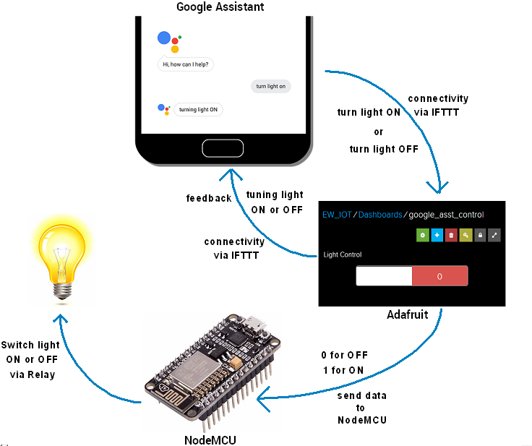

**Fig 1:Block Diagram**

When the voice command is given to the google assistant, through IFTTT protocol it communicates to the “Adafruit” where the command is verified and interpreted, the signal is passed on to the Node MCU(ESP8266). The signal is given to the specific appliances connected to the Node MCU and the desired action is performed according to the voice command given by the user.

Also, through the mobile application named “BLYNK” can be used to implement the same project with the same purpose. The application contains the E-switch which is already interfaced in the application itself.

6

**2.2:Circuit Diagram(interfacing diagram)**

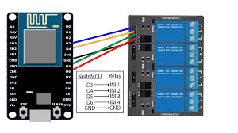

**Fig 2:interfacing diagram**

The code is uploaded to Node MCU using Arduino IDE. The 5V power supply is given to the Node MCU and the digital pins are connected to the input pins of the relay module according to the requirements using Jumper wires. The appliances are connected to the relay module.

**Working:**

In this project, the automation system is designed such a way that when the voice command is given to the google assistant, firstly the command is verified and then the IFTTT protocol comes into the scenario. This protocol works on the principle of “If This Then That”. In this protocol, on the backhand of this project, the voice commands are predefined using google assistant and Adafruit(data/conditions of the appliances are stored). When the voice command matches to this predefined command, then the action to be performed for the particular input command is interpreted and the signal is given to the Node MCU(ESP8266).

Now, for the signal to be received by Node MCU, it should have the Internet access without which the google assistant won’t be operated. When the signal is passed on to the Node MCU, the relay module is connected to the digital pins of Node MCU, and the home appliances are connected to that relay module. Thus, the appliances can be controlled and the automation system would work efficiently.

7

**CH:3 COMPONENTS AND ITS DETAILS**

**3.1:List of components**

* **Node MCU(ESP8266)**
* **4 channel relay module(5V)**
* **Jumper wires**

**3.2:Details of components**

**Node MCU-**

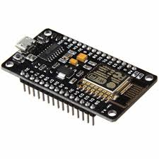

**Fig 3:Node MCU**

NodeMCU is an open-source firmware and development kit that helps you to prototype or build IoT product. It includes firmware which runs on the ESP8266 Wi-Fi SoC from Espressif Systems, and hardware which is based on the ESP-12 module. The firmware uses the Lua scripting language.

**4 channel 5V relay module-**

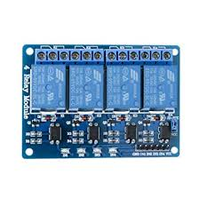

**Fig 4:Relay**

8

We can control high voltage electronic devices using relays. A Relay is actually a switch which is electrically operated by an electromagnet. The electromagnet is activated with a low voltage, for example 5 volts from a microcontroller and it pulls a contact to make or break a high voltage circuit. It works on the principle of an electromagnetic attraction. When the circuit of therelay senses the fault current, it energises the electromagnetic field which produces the temporary magneticfield. The current flows through the coil produces the magnetic field around it.

**Jumper wires-**

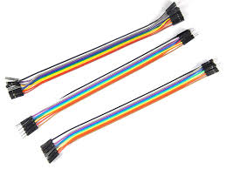

**Fig 5: Wires**

It is used to connect the circuit for the flow of the signal through different devices.

9

**CH:4 IMPLEMENTATION**

**4.1:Hardware Implementation**

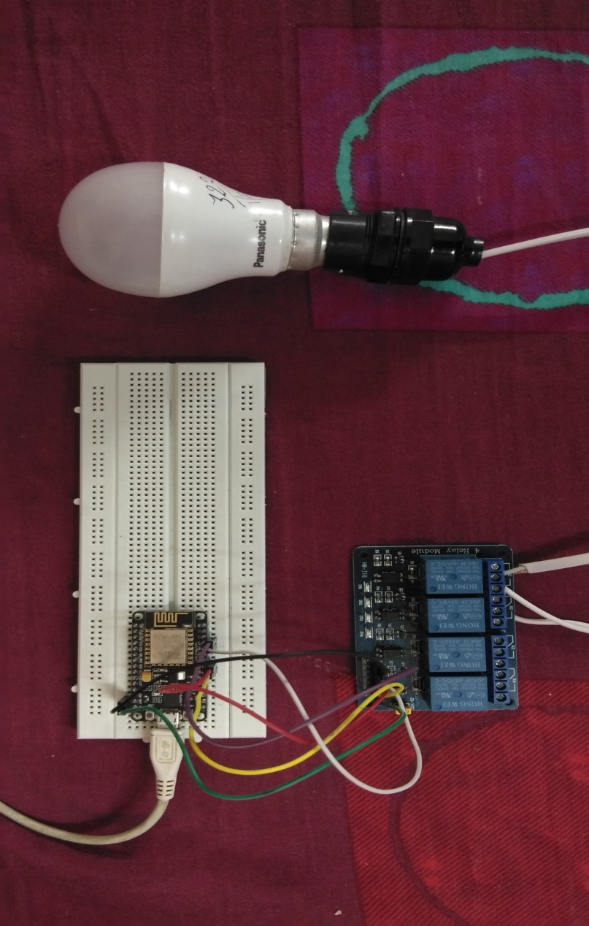

**Fig 6:Hardware**

10

**CH:5 APPLICATIONS AND ITS FUTURE SCOPES**

**5.1:Applications**

* In large scale industries, automation system helps to reduce the manual work and the efficiency is increased.
* Home security and maintenance
* In agricultural field, IoT based automation systems makes the manual and hectic tasks easy for farmers and the maintenance of the field is being done on a regular basis.
* For military purpose, the automation system can be a great deal for the matter of security. Robotic soldiers can be deployed on the border which would be completely automated. Thus, national security won’t cost us any lives.

**5.2:Future scopes**

* Internet of things would be used for Big Data Analysis, the large scale systems would be IoT based automation systems.
* People would be able to control and maintain their homes with just a single touch through their cell phones.
* Internet of Things would make the future world and generations smarter and capable.

11

**CONCLUSION**

In this paper, a prototype smart homee automation using IoT is presented. This research work will be carried forward by integrating relays to Arduino board or Node MCU for controlling home appliances from a remote location in a real scenario. As an extension, authors propose a generic IoT framework and use cloud computing infrastructure for connecting and managing remote devices and also store sensor data. Authors plan to productize proposed home automation solution so that more number of people can use IoT in a smart environment. The final system created is capable of recognizing the voice commands and gives an appropriate response to the user. IO commands like light on and light off work perfectly.

12

**REFERENCES**

[1] Mohamed Sultan,Department of Electronics, Faculty of Engineering, Cairo University, Egypt, Mohamedsultan Khaled Nabil,Prof. of Building Technology, Department of Architecture, Faculty of Engineering, Zagazig University, Egypt, King Abd-ElAziz University, Saudi Arabia

[2] Harsh Kumar Singh, Saurabh Verma, Shashank Pal, Kavita Pandey Department of Computer Science and Engineering, Jaypee Institute of Information Technology

[3]Voice controlled home automation system using natural language processing (NLP) and Internet of Things(IoT), Mrs. Paul Jasmin Rani, Jason Baktha kumar, Praveen Kumar, Praveen Kumar and Santhosh Kumar

[4] Mobile based Horne Automation using Internet of Things(IoT), Kumar Mandula, Ramu Parupalli, CH.A.S.Murty, E.Magesh, Rutul Lunagariya Centre for Development of Advanced Computing(C-DAC)

[5] Enabling IoT services using WiFi -Zigbee gateway for a home automation system, Vivek G.V Department of Electronics and Communication Engineering School of Engineering and Technology, Jain University Kanakapura Taluk

[6] IoT Based Smart Security and Home Automation, Shradha Somani Parikshit Solunke

Department of Computer Engineering Department of Computer Engineering PVG’s COET

[7] Home Automation System using Internet of Things (IOT), Akhil Jain1, Poonam Tanwar, Stuti Mehra*,* Lingaya’s University, Manav Rachna International Institute of Research and Studies, Faridabad, Haryana, India

[8] Design and Implementation of IoT-Based Automation System for Smart Home, Waheb A. Jabbar, Mohammed Hayyan Alsibai, Nur Syaira S. Amran, and Samiah K. Mahayadin Faculty of Engineering Technology, Universiti Malaysia Pahang, 26300 Gambang, Kuantan, Pahang, Malaysia

[9] An IoT based Home Automation Using Android Application,

Siva Nagendra Reddy, Tharun Kumar Reddy, Ajay Kumar Reddy, Dr.G.N.Kodanda

Ramaiah, S.Nanda Kishor

[10] <https://www.electronicwings.com/nodemcu/control-home-appliances-using-google-assistant>

13

**DATA-SHEETS OF COMPONENTS**

**Node MCU:**

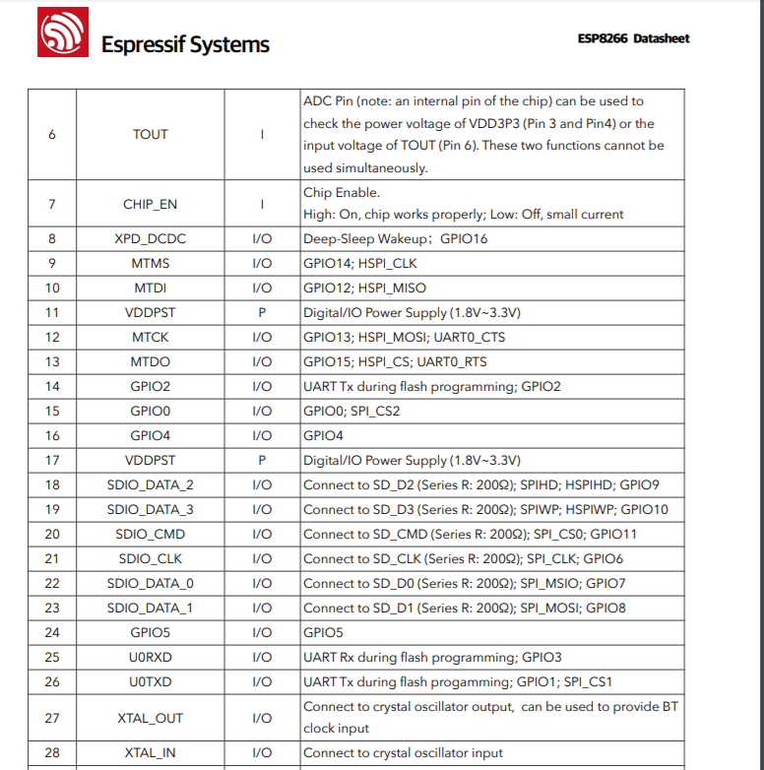

14

**Relay Module:**

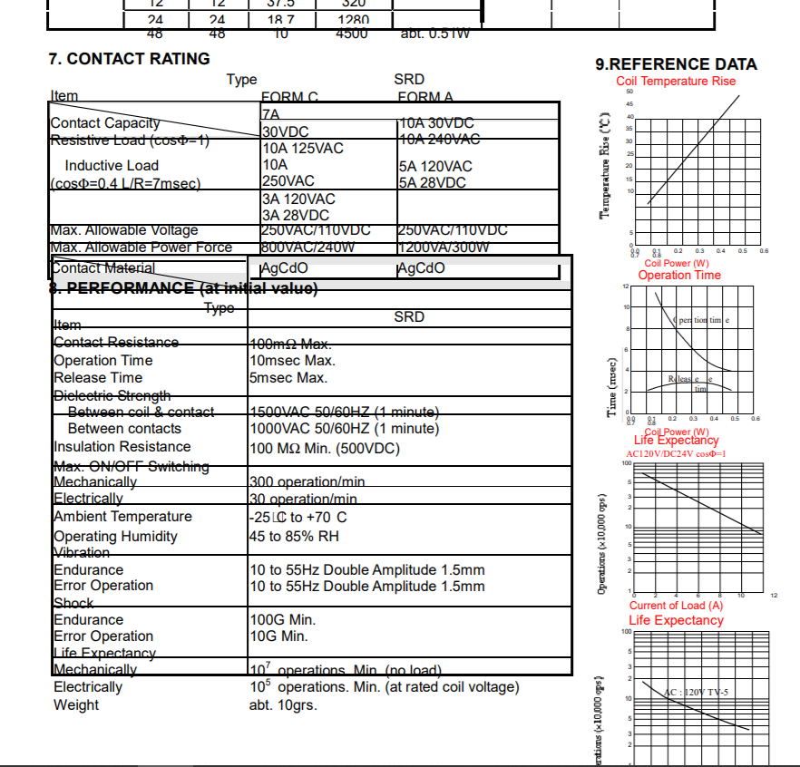

15